

Minutes of Joint Policing Meeting held in the Council Chamber,
Market Square Longford on
Monday, 10th September 2018 at 3.00 p.m.

PRESIDING: Councillor Gerry Warnock

PRESENT: Councillors - John Browne, Mick Cahill, Colm Murray, Martin Mulleady, Peggy Nolan, Pat O’Toole and Paul Ross

Mr. Luke Casey, Ms. Rosalind Greene and
Ms. Emma Kiernan

Mr. Paddy Mahon, Chief Executive
Ms. Barbara Heslin, Director of Services
Mr. Ciaran Murphy, Senior Executive Officer

Chief Supt. Tony Healy
Supt. Jim Delaney
Supt. Brian Mohan
Inspector Blaithin Moran
Sergeant Patrick Conway

APOLOGIES:- Councillors - Paraic Brady, Seamus Butler, Gerard Farrell, Joe Flaherty and P.J. Reilly

Ms. Madeline Bennett and Mr. Peter Cox

ACTING MEETINGS
ADMINISTRATOR: Mary Cooney

The Chair welcomed Chief Superintendent for the Roscommon/Longford Division, Tony Healy and Sergeant Patrick Conway, Secretary CCTV Advisory Committee to the meeting.

ADOPTION OF MINUTES.

On the proposal of Councillor C. Murray seconded by Councillor P. Nolan, it was unanimously agreed to adopt the minutes of Joint Policing Committee meetings held on the 11th June 2018, as circulated.
MATTERS ARISING.

None.

GARDA REPORT

Supt. Mohan briefed the members on the following and replied to queries raised –

- Statistics -
  - Burglaries
  - Serious incidents
  - Speeding incidents
- Thefts from retail premises.
- Road traffic accidents.
- Additional Garda resources allocated to Edgeworthstown and Granard Garda Stations.
- Success of policing control at the Marquee in Drumlish Festival and Granard Agricultural Show, from Gardai perspective.

Supt. Mohan emphasised the need for shopkeepers to be aware of security when placing high value goods at the entrance to their premises.

Councillor M. Mulleady, on behalf of the Festival Committee thanked An Garda Síochána for their assistance at the 2018 Drumlish Festival, which went off without incident.

Supt. Delaney briefed the members on the following and replied to queries raised –

- Statistics -
  - High volume crime
  - Burglaries
  - Shop theft
  - Public Order incidents
  - Serious incidents
  - Roads Policing
- Additional Garda resources allocated to Longford Garda Station.
- An Open Day at Longford Garda Station to be held on 22nd September
- Increased visibility at sporting events, festivals and checkpoints.
- Serious stabbing incident - offender detained within 48 hours.
- Community Policing Units
- Drugs - 16 people charged and prosecution ongoing.

Councillor C. Murray thanked An Garda Síochána for their assistance at a recent GAA match and Councillor J. Browne congratulated An Garda Síochána on arrests made following drugs raids carried out recently.

LOCAL AUTHORITY REPORT

Mr. C. Murphy, Senior Executive Officer, updated the members on the following and replied to queries raised -

- Funding Programmes.
- Ballyminion Draft Masterplan.
- Applications for Urban and Rural Regeneration and Development Fund being prepared.
- Connolly Barracks.
- Granard Motte.
- Old Schoolhouse in Edgeworthstown.
- Housing constructions in progress.
- Refurbishment of Voids in progress.
- Environment prevention and enforcement.
- Cemeteries.

CCTV.

Sergeant Patrick Conway updated the members in relation to the Community Based CCTV Scheme. He advised that the delay in finalising the announcement of approved applicants was due to GDPR and Data Protection issues regarding access to information recorded on CCTV. These issues have been resolved and all applications have now been signed.

The news was warmly welcomed by the JPC Committee.

Supt. Delaney advised that a special steering committee is now set up between Longford County Council and An Garda Síochána to progress the enhancement and expansion of the CCTV system for Longford town.

Councillor P. Nolan requested that regular progress reports be submitted to the JPC Committee.

Councillor P. Ross requested that the JPC Committee have input into locations identified for the installation of new CCTV, which was agreed by the Chair.

UPDATE ON LONGFORD JOINT ACTION PLAN

Mr. P. Mahon, Chief Executive briefed the members on actions completed on the Pilot Programme for Ardnacassa Regeneration. He advised that as the Pilot programme is at approximately half-way stage, it is proposed to conduct a Review towards the end of year. The second stage of the Pilot is to focus on building capacity within the different communities.

Supt. Delaney gave the statistics where the Gardai were proactively engaged.

Councillor P. Nolan asked for notification on the date arranged to meet with the communities.
ARRANGEMENTS FOR 2018 PUBLIC MEETING

On the proposal of Councillor C. Murray, seconded by Councillor P. Nolan, it was unanimously agreed that the 2018 Joint Policing Public Meeting be held at 7.00 p.m. on Monday 5th November in Ballymahon Library. The theme for this year’s meeting is “Crime Prevention”.

Councillor P. Nolan proposed and Councillor C. Murray seconded that Garda Commissioner Drew Harris be invited as Guest Speaker for the event.

It was also agreed to invite Ms. Josephone Feehily, Chairperson of the Joint Policing Authority, as Guest Speaker.

A.O.B.

None

Chief Supt. Tony Healy then closed the meeting.

He underlined his full support for Joint Policing Committees and stated that his goals include public accountability; high visibility policing through beats and patrols; community engagement and proactive preventative policing.

He welcomes feedback from the Elected Members and looks forward to working with all members of the Joint Policing Committee to build a safer environment.

DATE OF NEXT MEETING

It was agreed that the next meeting be held on Monday, 3rd December 2018.

This concluded the business of the meeting.
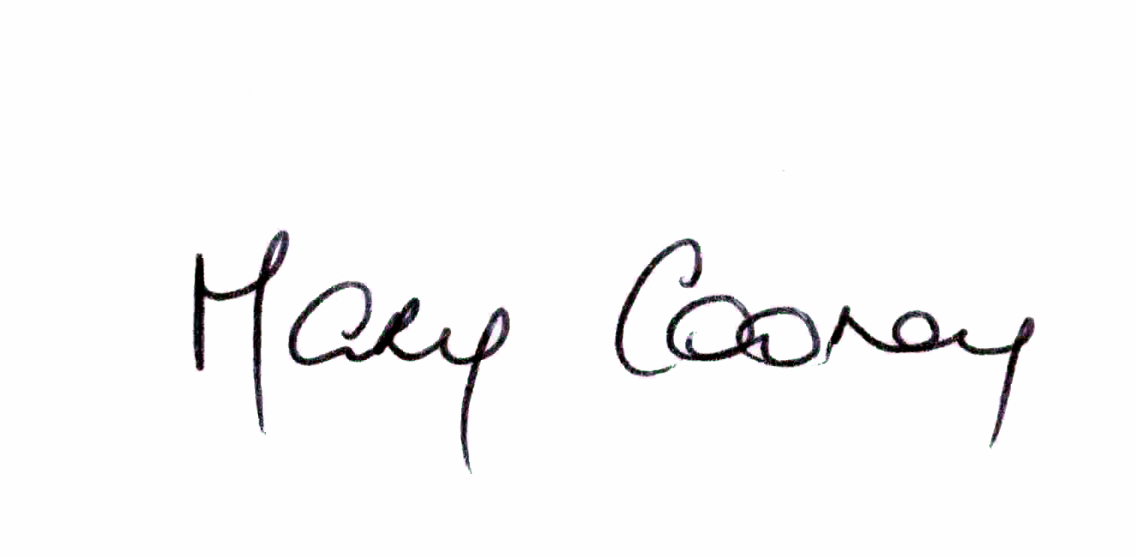

Signed:
Mary Cooney,
A/ Meetings Administrator.

Confirmed and adopted at Joint Policing Committee Meeting held on the
3rd December 2018.

Signed: __________________
Chairperson.

